 **SENECT : Where Experience Meets Innovation**

A

Project Report

Submitted in partial fulfilment of the requirement for the award of degree of

**Bachelor of Technology**

In

**Information Technology**

Submitted to

**RAJIV GANDHI PROUDYOGIKI VISHWAVIDYALAYA,**

**BHOPAL (M.P.)**

Guided By: Submitted By:

Prof. Kapil Sahu Riddhi Pathak (0827IT221120)

Sakshi Pandya (0827IT221127)

Saloni Jain (0827IT221128)

Shivani Bafna (0827IT233D09)

**DEPARTMENT OF INFORMATION TECHNOLOGY**

**ACROPOLIS INSTITUTE OF TECHNOLOGY & RESEARCH,**

**INDORE (M.P.) 452020**

**2024-2025**

# **DECLARATION**

I hereby declared that the work, which is being presented in the project entitled **SENECT** partial fulfilment of the requirement for the award of the degree of **Bachelor of Technology**, submitted in the Department of Information Technology at **Acropolis Institute of Technology & Research, Indore** is an authentic record of my own work carried under the supervision of “**Prof. Kapil Sahu**”. I have not submitted the matter embodied in this report for the award of any other degree.

Submitted by:

Riddhi Pathak (0827IT221120)

Sakshi Pandya (0827IT221127) Saloni Jain (0827IT221128)

Shivani Bafna (0827IT233D09)

Prof. Kapil Sahu

**Supervisor**

# 

# **PROJECT APPROVAL FORM**

I hereby recommend that the project **SENECT** prepared under my supervision by **Riddhi Pathak (0827IT221120) , Sakshi Pandya (0827IT221127) , Saloni Jain (0827IT221128) , Shivani Bafna (0827IT233D09)** be accepted in partial fulfilment of the requirement for the degree of Bachelor of Technology in Information Technology.

Submitted by:

Riddhi Pathak(0827IT221120)

Sakshi Pandya (0827IT221127) Saloni Jain (0827IT221128)

Shivani Bafna (0827IT233D09)

Prof. Kapil Sahu

**Supervisor**

Recommendation concurred in 2024-2025

Prof. Monika Chaudhary

**Project In charge**

Prof. Deepak Singh Chouhan

**Project Coordinator**

**Acropolis Institute of Technology & Research**

# **Department of Information Technology**

# **CERTIFICATE**

The project work entitled **SENECT** is approved as partial fulfilment for the award of the degree of Bachelor of Technology in Information Technology by Rajiv Gandhi Proudyogiki Vishwavidyalaya, Bhopal (M.P.).

Submitted by:

Riddhi Pathak (0827IT221120)

Sakshi Pandya (0827IT221127) Saloni Jain (0827IT221128)

Shivani Bafna (0827IT233D09)

Internal Examiner External Examiner

Name: …………… Name: ……………..

Date: …./…/……… Date: …./…/………..

# **ACKNOWLEDGEMENT**

With boundless love and appreciation, we would like to extend our heartfelt gratitude and appreciation to the people who helped us to bring this work to reality. We would like to have some space of acknowledgement for them.

Foremost, we would like to express our sincere gratitude to our supervisor **Prof. Kapil Sahu** whose expertise, consistent guidance, ample time spent and consistent advice that helped us to bring this study into success.

To the project in-charge **Prof. Monika Chaudhary** and project coordinator **Prof. Deepak Singh Chouhan** for their constructive comments, suggestions, and critiquing even in hardship.

To the honourable **Prof. (Dr.) Prashant Lakkadwala**, Head, Department of Information Technology for his favourable responses regarding the study and providing necessary facilities.

To the honourable **Dr. S.C. Sharma**, Director, AITR, Indore for his unending support, advice and effort to make it possible.

Finally, we would like to pay our thanks to faculty members and staff of the Department of Information Technology for their timely help and support.

We also like to pay thanks to our **parents** for their eternal love, support and prayers without them it is not possible.

Riddhi Pathak (0827IT221120)

Sakshi Pandya (0827IT221127) Saloni Jain (0827IT221128)

Shivani Bafna (0827IT233D09)

## **ABSTRACT**

The SENECT is a web application designed to bridge the gap between alumni and students of a university, fostering meaningful connections and promoting professional growth. The application was developed to address key challenges faced by students, such as limited access to mentorship, lack of centralized resources, and the absence of a dedicated platform for connecting with alumni. By creating an all-in-one solution, SENECT aims to enhance the student experience through personalized guidance, networking opportunities, and community building.

The web application was developed using a combination of advanced technologies, including HTML, CSS and Bootstrap for front-end development to ensure cross-platform compatibility, Node.js with Express.js for a robust back end, and Firebase for efficient data storage and retrieval. Features such as secure private chat, voice and video calling, mentorship rooms, and alumni-led groups were incorporated to facilitate real-time interactions and create a trusted platform for users. The design and development were guided by frameworks like the Technology Adoption Model (TAM) to ensure user-friendliness and effective engagement.

Initial testing and analysis demonstrated the web application’s potential to address existing problems. Students reported easier access to mentorship and valuable career resources, while alumni expressed satisfaction in engaging with the university community and sharing expertise. The web application also showed a significant positive impact on community building and professional networking, creating a sense of belonging among users.

The findings underline the importance of leveraging technology to enhance student engagement, mentorship, and alumni relations in higher education settings. The SENECT web application provides a scalable and efficient solution for universities to improve their ecosystem by fostering connections, promoting knowledge sharing, and preparing students for future professional challenges. Its user-centric design and practical applications highlight its potential to become a transformative tool in education technology and alumni management.

# **TABLE OF CONTENT**

**Declaration ……………………………………………………………………….**pg no. 2

**Project Approval Form ………………………………………………………….**pg no. 3

**Acknowledgement ……………………………………………………………….**pg no. 5

**Abstract …………………………………………………………………………..**pg no. 6

**List of Figures…………………………………………………………………….**pg no. 10

**List of Tables………………………………………………………………….…..**pg no. 11

**Abbreviations………..……………………………………………………………**pg no. 12

**Chapter 1: Introduction**

1.1 Rationale ………………………………………………………………pg no. 13

1.2 Existing System ……………………………………………………….pg no. 13

1.3 Problem Formulation……….………………………………………….pg no. 13

1.4 Proposed System……………………………………………………….pg no. 13

1.5 Objectives………………………………………………………………pg no. 14

1.6 Contribution of the Project

1.6.1 Market Potential……………..……………………………….pg no. 14

1.6.2 Innovativeness…….………………………………………….pg no. 14

1.6.3 Usefulness…….…………………………………..………….pg no. 14

1.7 Report Organization…….……………………………………..……….pg no. 14

**Chapter 2: Requirement Engineering**

2.1 Feasibility Study (Technical, Economical, Operational) …….…..…….pg no. 16

2.2 Requirement Collection

2.2.1 Discussion…….……………………………………………….pg no. 16

2.2.2 Requirement Analysis…….…………………………………….pg no. 17

2.3 Requirements

2.3.1 Functional Requirements…….……………………………….pg no. 17

2.3.1.1 Statement of Functionality…………………

2.3.2 Nonfunctional Requirements…….…………………………….pg no. 17

2.3.2.1 Statement of Functionality………………….

2.4 Hardware & Software Requirements

2.4.1 Hardware Requirement (Developer & End User) …….…….…..pg no. 17

2.4.2 Software Requirement (Developer & End User) …….……...….pg no. 18

2.5 Use-case Diagrams…….………………………………………………...pg no. 19

2.5.1 Use-case Descriptions…….………………….………………..pg no. 20

**Chapter 3: Analysis & Conceptual Design & Technical Architecture**

3.1 Technical Architecture…….…………………………………………..…..pg no. 22

3.2 Sequence Diagrams…….………………..………………………………..pg no. 23

3.3 Class Diagrams…….……………………….……………………………..pg no. 24

3.4 DFD…….…………………………………..……………………………..pg no. 25

3.5 User Interface Design……...….…………………………………………..pg no. 26

3.6 Data Design

3.6.1 Schema Definitions…….…………………………………………pg no. 30

3.6.2 E-R Diagram…….……………………………..………………….pg no. 31

**Chapter 4: Implementation & Testing**

4.1 Methodology…….……………………………………………………….pg no. 32

4.1.1 Proposed Algorithm…….……………………….

4.2 Implementation Approach…….………………………………………….pg no. 33

4.2.1 Introduction to Languages, IDEs Tools and Technologies………..pg no. 33

4.3 Testing Approaches

4.3.1 Unit Testing

1. Test Cases…….……………………………………...……pg no. 33

4.3.2 Integration Testing

1. Test Cases…….……………………………………………pg no. 34

**Chapter 5: Results & Discussion**

5.1 User Interface Representation…….……………………………………..pg no. 36

* + 1. Brief Description of Various Modules…….…………………pg no. 36
  1. Snapshot of System with Brief Description…….…………………….……pg no. 36

5.3 Database Description…….……………………………………………..…….pg no. 37

5.3.1 Snapshot of Database Tables with Brief Description…….………….pg no. 37

5.4 Final Findings…….…………………………………………….…………….pg no. 38

1. **Conclusion & Future Scope**
   1. Conclusion………………………………………………………………...…pg no. 40
   2. Future Scope ………………………………………………………………....pg no. 40

**REFERENCES**

**Appendix A:** Project Synopsis

**Appendix B:** Guide Interaction Report

**Appendix C:** User Manual

**Appendix D:** Git/GitHub Commits/Version History

**List of Figures**

Use-case Diagram

Technical Architecture

Sequence Diagram

Class Diagram

Data Flow Diagram

User Interface Design

Data Design

Schema Definition

E-R Diagram

## **Abbreviations**

* **AI**: Artificial Intelligence
* **AWS**: Amazon Web Services
* **CSS**: Cascading Style Sheets
* **E-R**: Entity-Relationship
* **HTML**: Hyper Text Markup Language
* **IDE**: Integrated Development Environment
* **RESTful API**: Representational State Transfer Application Programming Interface

## **List of Tables**

* **Table 2.1**: Feasibility Study Analysis
* **Table 2.2**: Functional and Non-Functional Requirements
* **Table 2.3**: Hardware Requirements
* **Table 2.4**: Software Requirements
* **Table 3.1**: Technical Architecture Components
* **Table 3.2**: Data Schema Description
* **Table 4.1**: Proposed Algorithm Steps
* **Table 4.2**: Unit Testing Test Cases and Results
* **Table 4.3**: Integration Testing Test Cases and Results
* **Table 5.1**: Module Descriptions in the System
* **Table 5.2**: Database Tables with Fields and Descriptions

### **CHAPTER 1: INTRODUCTION**

**1.1 Rationale**

The need for effective student-alumni networking platforms has grown significantly in recent years. Universities lack centralized systems to facilitate communication and mentorship opportunities between students and alumni, leading to missed opportunities for guidance, career development, and collaboration. The SENECT web application addresses this gap by creating a secure, user-friendly platform to strengthen these connections, fostering professional and personal growth.

**1.2 Existing System**

Existing solutions like LinkedIn focus on general professional networking but fail to provide a dedicated space tailored to university communities. Additionally, traditional methods, such as email or university events, are often limited in scope, time-consuming, and lack real-time interaction capabilities.

**1.3 Problem Formulation**

* + Students often struggle to find suitable mentors for academic and professional guidance.
  + Alumni lack a streamlined way to connect with students and give back to their alma mater.
  + The absence of a dedicated platform results in poor utilization of alumni resources.

**1.4 Proposed System**

The SENECT web application bridges the gap between students and alumni by providing:

* *Real-time Communication*: Chat, voice, and video call features for seamless interaction.
* *Mentorship Rooms*: Secure virtual spaces for personalized guidance.
* *Skill Endorsements*: Alumni can validate students’ skills, enhancing their professional profiles.
* *Event Hosting*: Tools for alumni to organize webinars and collaborative activities.

**1.5 Objectives**

* Facilitate meaningful mentorship relationships between students and alumni.
* Enhance professional networking opportunities within the university ecosystem.
* Improve access to career resources and guidance.
* Strengthen university-alumni relations to benefit both parties.

**1.6 Contribution of the Project**

**1.6.1 Market Potential**

* The education technology market is expanding, and universities are increasingly adopting digital solutions to improve student experiences.
* SENECT stands out as a niche product tailored for university ecosystems, filling a critical gap in alumni-student engagement.

**1.6.2 Innovativeness**

* Combines real-time communication tools, mentorship rooms, and skill endorsements in a single platform.
* Offers a user-friendly mobile application powered by modern technologies like HTML, CSS, Bootstrap, Firebase and Node.js.

**1.6.3 Usefulness**

* Provides students with access to valuable career advice, job opportunities, and academic support.
* Enables alumni to give back to their university by mentoring and endorsing skills proposed solution, and objectives.

**1.7 Report Organization**

This report is structured to provide a comprehensive understanding of the SENECT platform, its objectives, and its potential impact on enhancing alumni-student relationships. The organization of the report is as follows:

* Chapter 2: Requirement Engineering, including feasibility studies and requirements analysis.
* Chapter 3: Analysis & Conceptual Design & Technical Architecture
* Chapter 4: Implementation & Testing, detailing development tools, methodologies, and testing strategies.
* Chapter 5: Results & Discussion, presenting the user interface, system snapshots, and database structure.
* Chapter 6: Conclusion & Future Scope, summarizing the project’s impact and potential enhancements.

## **CHAPTER 2: REQUIREMENT ENGINEERING**

### **2.1 Feasibility Study**

* Technical Feasibility:

The project utilizes modern technologies such as HTML, CSS, Bootstrap, Firebase, and Node.js, ensuring compatibility and scalability. These technologies are widely supported and provide the necessary infrastructure for efficient development and deployment. The availability of cloud hosting platforms like AWS further enhances technical feasibility.

* Economic Feasibility:

The web application is cost-effective due to the use of open-source technologies and free development tools. Minimal investment is required for cloud hosting and database management, making it suitable for implementation within university budgets.

* Operational Feasibility:

SENECT is designed to address existing operational gaps in student-alumni communication. Its user-friendly interface and intuitive design ensure ease of use, while its features align with the needs of both students and alumni, enhancing acceptance and operational success.

**Table 2.1**: Feasibility Study Analysis

### **2.2 Requirement Collection**

**2.2.1 Discussion**

Requirements were gathered through brainstorming sessions with stakeholders, including students, alumni, and university representatives. User surveys and interviews were conducted to identify pain points and desired features.

**2.2.2 Requirement Analysis**

The analysis focused on categorizing requirements into functional and non-functional groups, prioritizing features based on their impact and feasibility. Core features such as chat, video calling, and skill endorsements were identified as essential, while additional features like event hosting were considered secondary.

### **2.3 Requirements**

**2.3.1 Functional Requirements**

**2.3.1.1 Statement of Functionality**

* Users should be able to register, log in, and manage their profiles.
* The system should facilitate real-time communication via chat, voice, and video calls.
* Alumni should be able to endorse students' skills and organize events.
* The platform should provide mentorship rooms for secure video-based interactions.
* The system should maintain user privacy and ensure secure data handling.
  + 1. **Non-Functional Requirements**

**2.3.2.1 Statement of Functionality**

* The app should be accessible on all web browsers.
* It should have low latency for real-time communication.
* The system should ensure 99.9% uptime with minimal disruptions.
* Data should be securely stored and protected against unauthorized access.
* A screen shot of a computer

  Description automatically generatedThe interface should be user-friendly and accessible to individuals with varying technical skills.

**Table 2.2**: Functional and Non-Functional Requirements

### **2.4 Hardware & Software Requirements**

**2.4.1 Hardware Requirements**

* Developer:
  + High-performance PC with at least 16GB RAM and an Intel i7 processor.
  + Stable internet connection.
* End User:
  + High-performance PC with at least 8 GB RAM and an Intel i5 processor.
  + Stable internet connection.

**Table 2.3**: Hardware Requirements

**2.4.2 Software Requirements**

* Developer:
  + Operating System: Windows/Linux/macOS.
  + IDE: Visual Studio Code.
  + Tools: HTML, CSS, Bootstrap, Node.js, Firebase, Git.
* End User:
  + Operating System: Web Browser.
  + Website: SENECT web application.

**Table 2.4**: Software Requirements

**2.5 Use-case Diagram:**

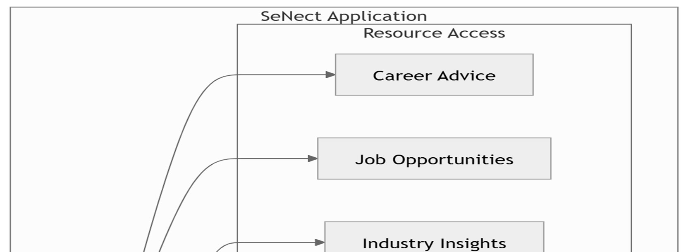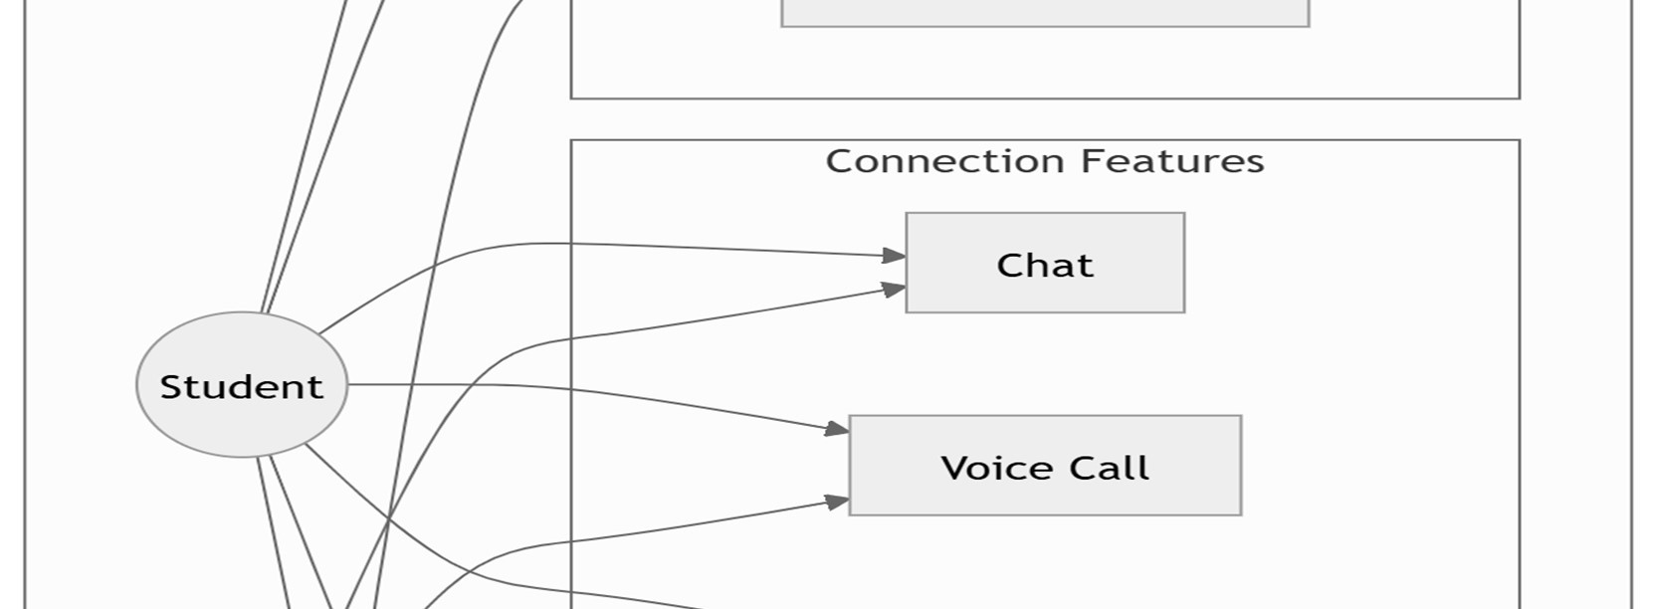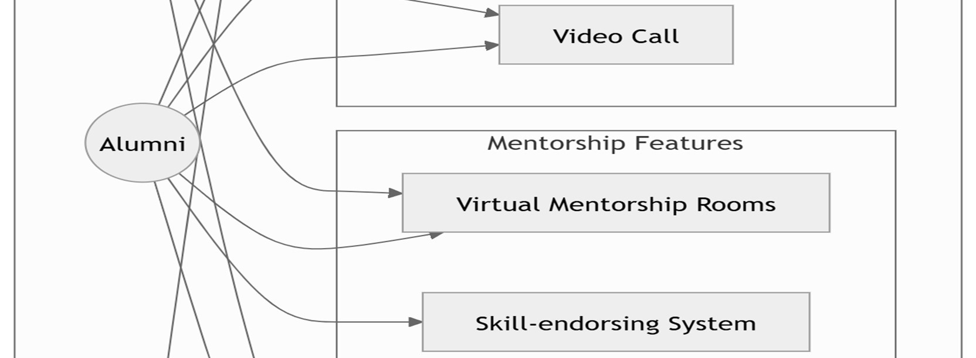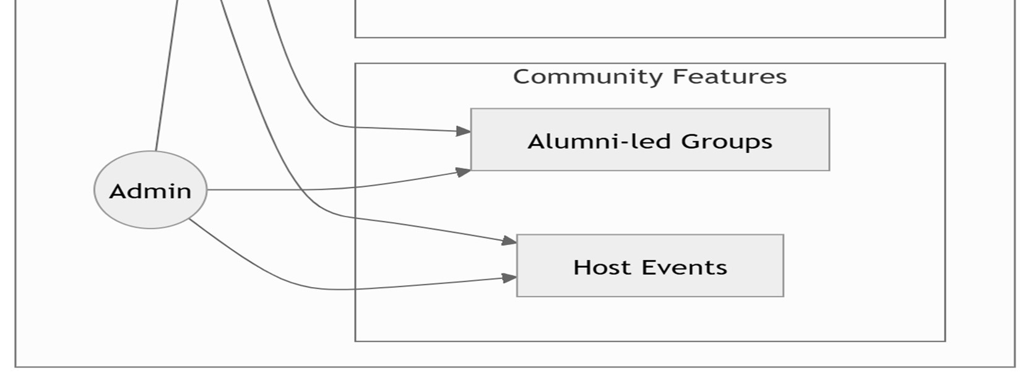

**Fig.1** Use Case Diagram

**2.5.1 Use-case Descriptions**

* User Registration and Login
  + Actors: Student, Alumni, Admin.
  + Description: All users must register and log in to the platform using a secure authentication system. Upon logging in, they gain access to features based on their role (Student, Alumni, or Admin).
* Accessing Resources (Career Advice, Job Opportunities, Industry Insights)
  + Actor: Student.
  + Description: Students can access a library of resources provided by alumni or the university, such as career advice articles, job postings, and industry insights, to enhance their knowledge and career readiness.
* Real-time Communication
  + Actors: Student, Alumni.
  + Description: Students and alumni can interact through chat, voice calls, or video calls. These features ensure seamless communication, allowing users to connect in real-time for mentorship, discussions, or networking.
* Mentorship Sessions
  + Actors: Student, Alumni.
  + Description: Students can schedule and participate in secure virtual mentorship sessions with alumni in "Virtual Mentorship Rooms." These sessions enable personalized guidance for academic or career-related queries.
* Skill Endorsement
  + Actor: Alumni.
  + Description: Alumni can endorse specific skills on a student’s profile, providing credibility and enhancing the student’s professional profile.
* Alumni-led Groups
  + Actor: Alumni.
  + Description: Alumni can create and manage groups based on shared interests, industries, or goals. These groups foster collaboration, networking, and knowledge-sharing between students and alumni.
* Event Hosting
  + Actors: Alumni, Admin.
  + Description: Alumni can host events such as webinars, networking sessions, or collaborative research discussions. Admins oversee the event approval process and ensure adherence to platform guidelines.

This description captures the key functionalities represented in the uploaded use-case diagram, focusing on the interactions between the actors and system features.

## **CHAPTER 3: ANALYSIS & CONCEPTUAL DESIGN & TECHNICAL ARCHITECTURE**

### **3.1 Technical Architecture**

**Fig. 2** Technical Architecture

**Table 3.1**: Technical Architecture Component

## **3.2 Sequence Diagram**

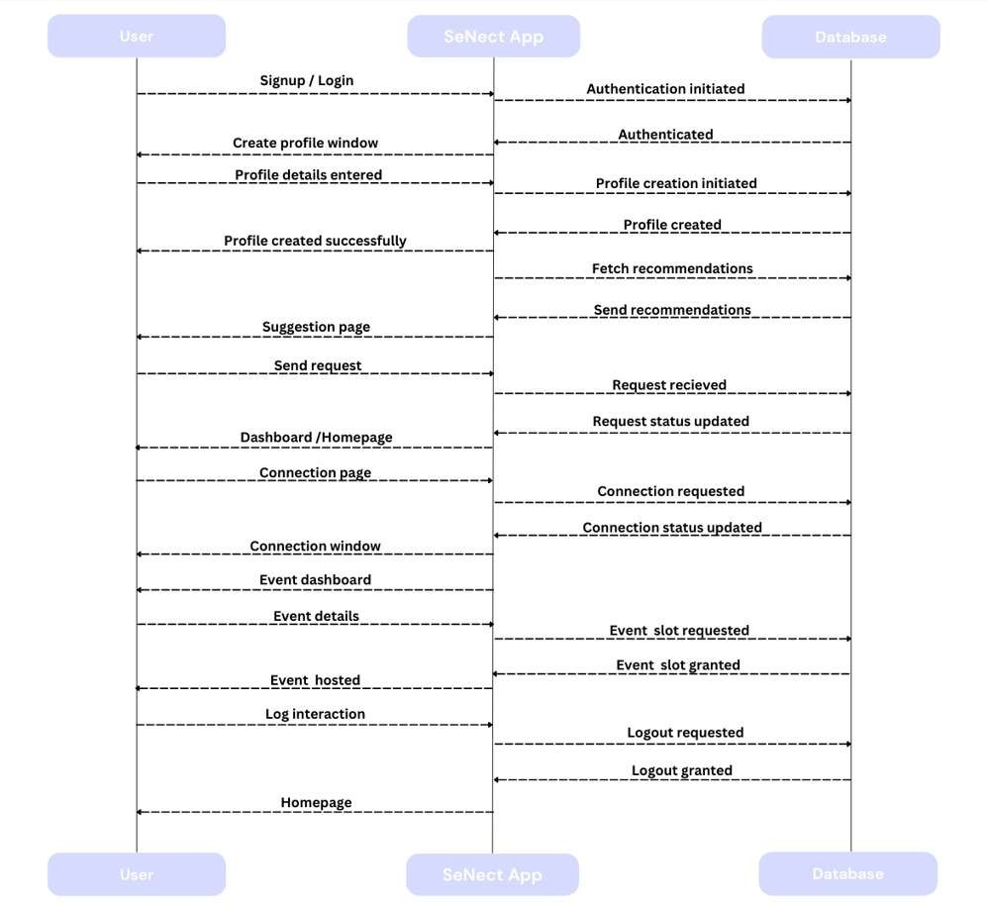

**Fig. 3** Sequence Diagram

## **3.3 Class Diagram**

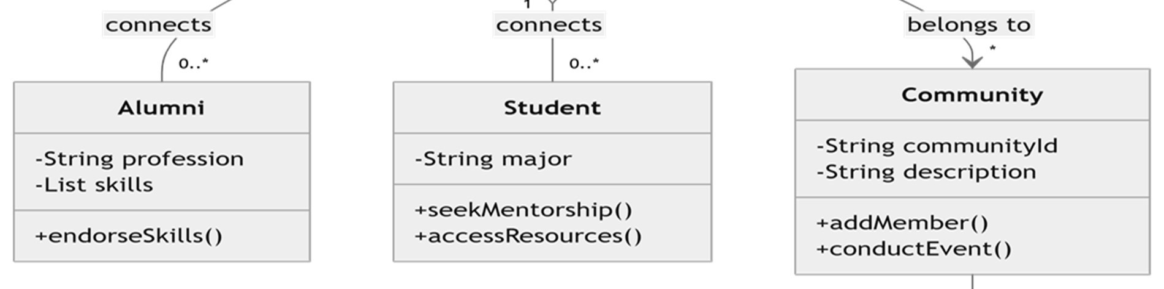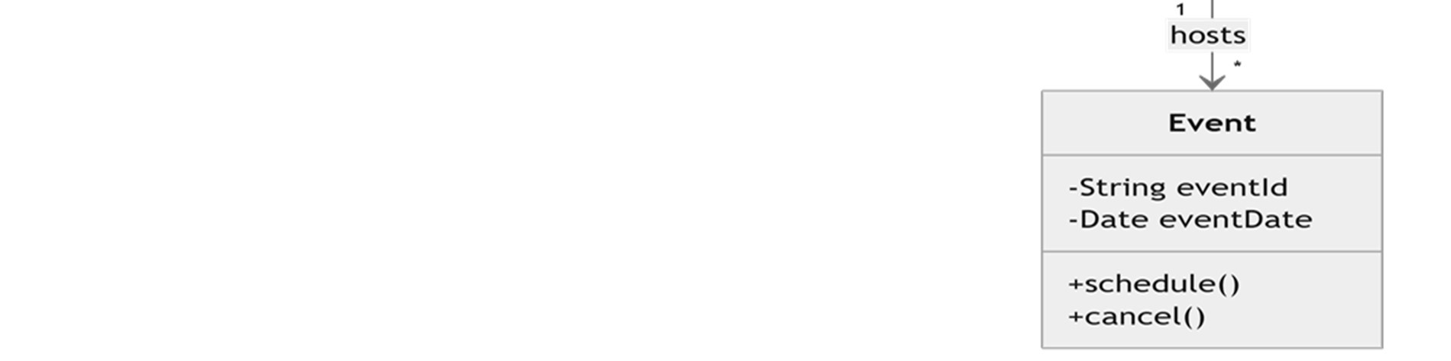

**Fig. 4** Class Diagram

**3**.**4 Data Flow Diagram**

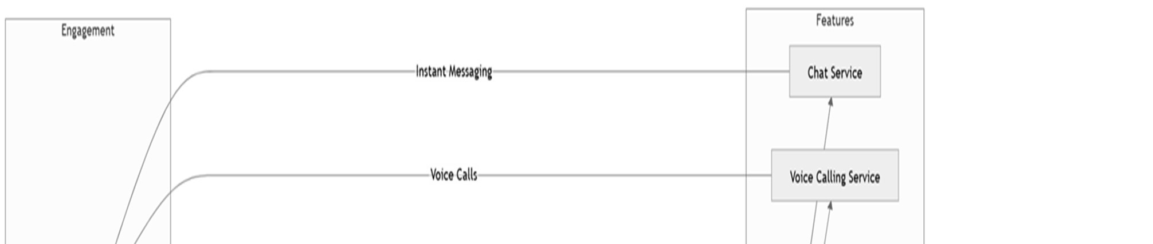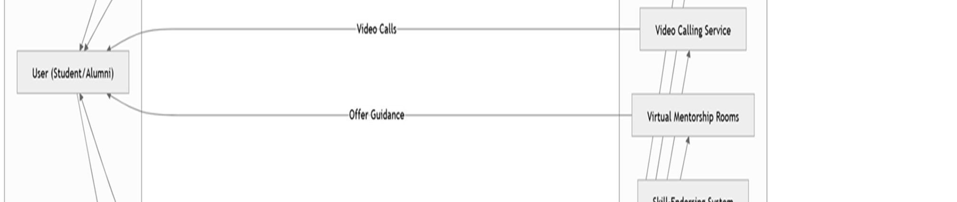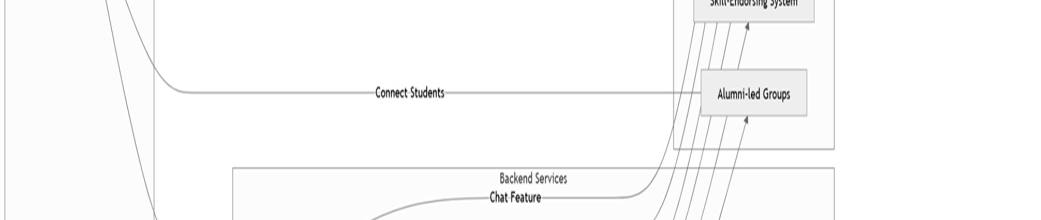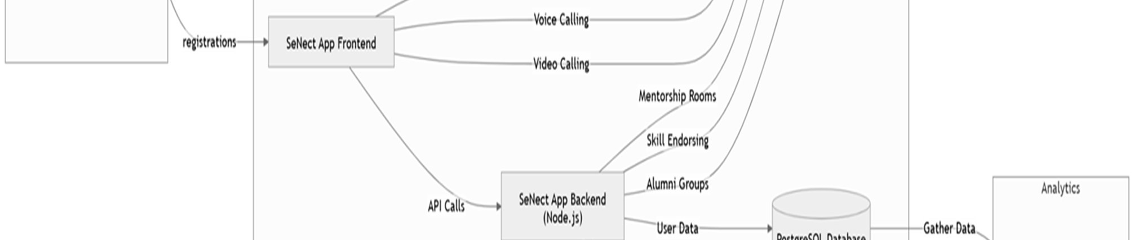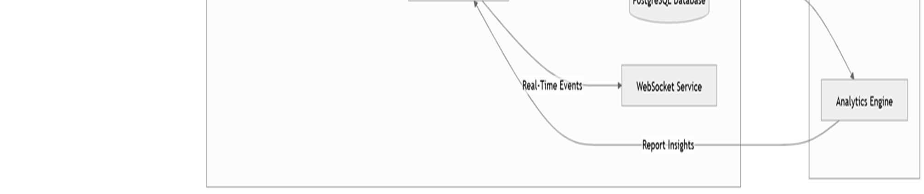

**Fig. 5** Data Flow Diagram

## 3.5 User Interface Design

**Fig. 6** Home page (part-1)

**Fig. 7** Home page (part-2)

**Fig. 8** Home page (part-3)

**Fig. 9** Sign up page

**Fig. 10** Login page

**Fig. 11** Our profile

**Fig. 12** My profile

**Fig. 13** Edit Profile

**3.6 Data Design**

**3.6.1 Schema Definitions**

* This schema represents a system where users (students and alumni) can interact through events, chats, profiles, and connections.
* The USER table is central, with STUDENT and ALUMNI inheriting its attributes to represent specific roles.
* ALUMNI can host events, while STUDENT can attend them, managed via the EVENT and EVENT_ATTENDEES tables for many-to-many relationships.
* Users can create PROFILE entries for additional personal details, initiate CHAT interactions, and form CONNECTIONS with other users.
* The schema efficiently supports networking, communication, and event participation features.

**Table 3.2**: Data Schema Description

### **3.6.2 E-R Diagram**

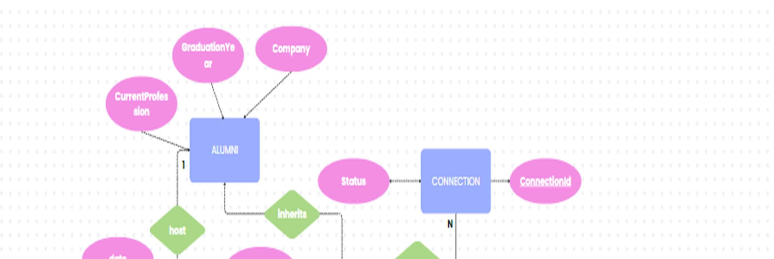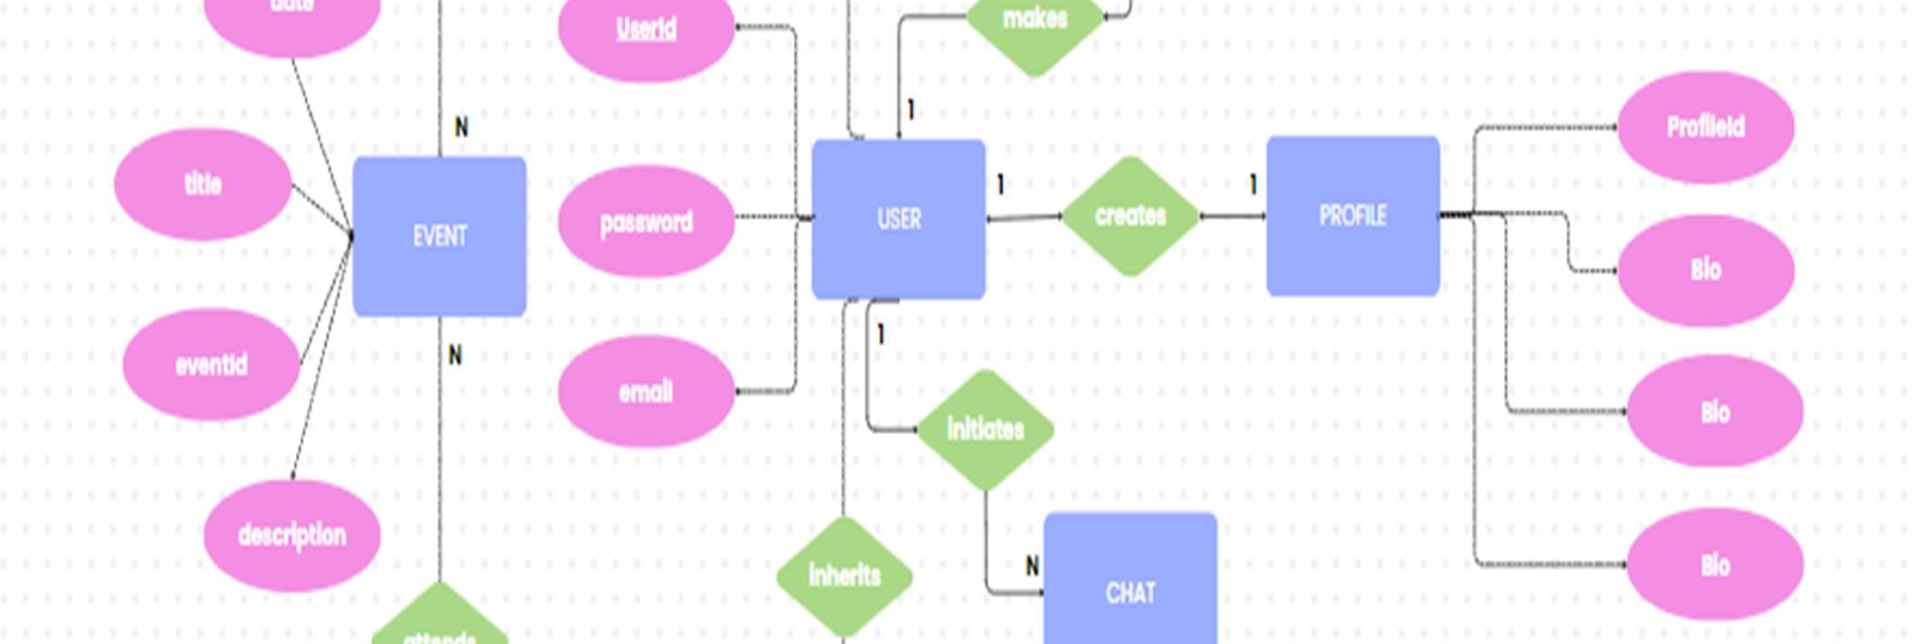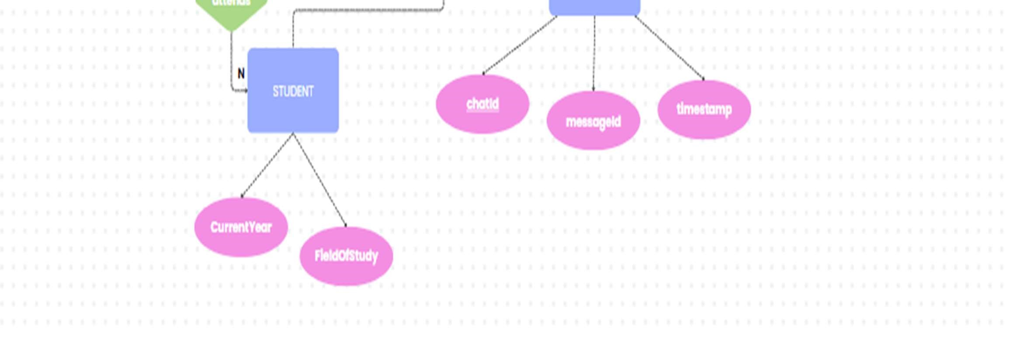

**Fig. 14** ER-Diagram

## **CHAPTER 4: IMPLEMENTATION & TESTING**

### **4.1 Methodology**

The development methodology for the SENECT website based on an Agile Development Framework, emphasizing iterative and incremental progress with a focus on user-centric design. Regular feedback loops were employed to refine the features and ensure alignment with user needs.

#### **4.1.1 Proposed Algorithm**

The website incorporates multiple algorithms for efficient data handling and communication, including:

* User Matching Algorithm: Matches students with alumni based on shared interests, academic background, or career aspirations.

Steps:

1. Input user profiles, including skills, interests, and academic details.
2. Calculate similarity scores using a weighted matrix.

3. Suggest top matches with high similarity scores.

* Real-Time Communication Protocol: Ensures seamless interaction via chat, voice, and video.

Steps:

1. Establish secure WebSocket connections.
2. Encode and transmit data packets in real time.
3. Synchronize client-server communication to maintain low latency.

**Table 4.1**: Proposed Algorithm Steps

**4.2 Implementation Approach**

**4.2.1 Introduction to Languages, IDEs, Tools, and Technologies**

* Front-End Development:
  + - * Language: HTML, CSS
      * Framework: Bootstrap
      * Features: Responsive UI, animations, and accessibility.
* Back-End Development:
  + Language: JavaScript
  + Framework: Node.js with Express.js for efficient server-side logic.
  + Features: RESTful APIs for seamless data exchange.
* Database:
  + System: Firebase for relational database management.
  + Features: Data indexing, backup support, and optimized queries.
* IDEs and Tools:
  + IDE: Visual Studio Code for development.
  + Version Control: Git and GitHub for source code management.
  + Cloud Deployment: AWS for hosting

### **4.3 Testing Approaches**

**4.3.1 Unit Testing**

Unit testing focused on validating individual components of the app to ensure their correctness.

Test Cases:

1. Login Feature:

* Input: Correct username and password.
* Expected Output: Successful login.
* Result: Pass.

2. Chat Functionality:

* Input: Message input from user A.
* Expected Output: Message delivered to user B in real-time.
* Result: Pass.

3. Skill Endorsement:

* Input: Alumni endorses a student' skill.
* Expected Output: Skill endorsement reflected in the student's profile.
* Result: Pass.

**Table 4.2**: Unit Testing Test Cases and Results

**4.3.2 Integration Testing**

Integration testing ensured seamless communication between the front-end, back-end, and database.

Test Cases:

1. User Registration:

* Test: Front-end submits registration form to the server.
* Expected Output: User details saved in the database and acknowledgment returned.
* Result: Pass.

2. Voice Calling:

* Test: User A initiates a call to user B.
* Expected Output: Call notification received by user B, and audio communication established.
* Result: Pass.

3. Database Query Performance:

* Test: Retrieve user profile with endorsements.
* Expected Output: Profile data loaded within 2 seconds.
* Result: Pass.

**Table 4.3**: Integration Testing Test Cases and Results

## **CHAPTER 5: RESULTS & DISCUSSION**

### **5.1 User Interface Representation**

**5.1.1 Brief Description of Various Modules**

* Login and Registration Module: Provides secure access to users with options for registration, login, and password recovery.
* Dashboard Module: Displays an overview of activities, notifications, and quick access to key features like mentorship rooms and groups.
* Mentorship Rooms: Facilitates secure video-based mentorship sessions between students and alumni.
* Chat and Calling Module: Includes real-time chat, voice, and video call features for seamless communication.
* Skill Endorsement Module: Allows alumni to endorse student skills, enhancing their professional profiles.
* A screenshot of a computer

  Description automatically generatedEvent Management Module: Enables alumni to create and manage events or webinars.

**Table 5.1**: Module Descriptions in the System

### **5.2 Snapshot of System with Brief Description**

* Login Screen: User-friendly interface for logging into the system with email and password authentication.
* Dashboard: A centralized view showing user statistics, recent messages, and suggested alumni connections.
* Chat Window: Real-time messaging interface with options for sending text, images, and files.
* Mentorship Room: Interactive video call screen with integrated notetaking and resource sharing.
* User Profile: Displays user details, skills, endorsements, and connection history.

### **5.3 Database Description**

**5.3.1 Snapshot of Database Tables with Brief Description**

1. Users Table:

* Fields: UserID, Name, Email, Password, Role (Student/Alumni), Profile Picture.
* Purpose: Stores user details and access credentials.

2. MentorshipSessions Table:

* Fields: SessionID, MentorID, MenteeID, Date, Duration, Notes.
* Purpose: Tracks details of mentorship sessions.

3. Messages Table:

* Fields: MessageID, SenderID, ReceiverID, Content, Timestamp.
* Purpose: Stores chat messages for real-time communication.

4. Events Table:

* Fields: EventID, OrganizerID, Title, Description, Date, Time, Location.
* Purpose: Manages alumni-hosted events.

5. Endorsements Table:

* Fields: EndorsementID, EndorserID, EndorseeID, Skill, Timestamp.
* A screenshot of a computer

  Description automatically generatedPurpose: Tracks skill endorsements given by alumni.

**Table 5.2**: Database Tables with Fields and Descriptions

### 5.4 Final Findings

1. The SENECT successfully bridges the gap between students and alumni by providing real-time communication and professional networking tools.
2. Features like mentorship rooms and skill endorsements enhance the overall user experience and add value to both students and alumni.
3. System testing results indicate robust functionality, with all major modules performing as expected.
4. User feedback highlights the ease of use, especially the chat and mentorship features.

## **Chapter 6: Conclusion & Future Scope**

### 6.1 Conclusion

The SENECT Application provides a robust and scalable platform that successfully bridges the gap between students and alumni, fostering an ecosystem of mentorship, networking, and professional collaboration. By integrating modern technologies like React.js, Node.js, and Firebase, the application ensures an efficient, secure, and responsive user experience across devices. Its core features, such as profile creation, user authentication, and communication modules, allow users to connect meaningfully, share insights, and collaborate on academic or professional growth. SENECT’s intuitive interface promotes seamless engagement, enabling alumni to provide career guidance while empowering students to seek mentorship and learning opportunities. The platform aligns with the growing need for connected communities, acting as a stepping stone for students transitioning into the professional world. Overall, SENECT serves as a vital tool for nurturing long-term professional relationships and fostering innovation through experience sharing.

### 6.2 Future Scope

The SENECT application has immense potential for further development and innovation to

address evolving user needs and technological advancements.

* **AI-Powered Matching System**: Integrating advanced machine learning algorithms to provide personalized mentor/mentee recommendations based on profiles, skills, goals, and interests.
* **Mobile Application**: Developing a dedicated mobile app for iOS and Android to ensure on-the-go access and user engagement.
* **Advanced Analytics Dashboard**: Introducing dashboards for administrators and users to track interactions, platform engagement, connection statistics, and other performance metrics.
* **Integration with Job Portals**: Collaborating with recruitment platforms to provide job postings, internship opportunities, and career resources for students and alumni.

**REFERENCES**

1. LinkedIn. *Professional Networking Platform*. Available at: [www.linkedin.com](https://www.linkedin.com) [Accessed Dec 2024].
2. “The Impact of Mentorship on Student Success" by J. M. Jenkins and A. M. Johnson (Journal of Educational Research, 2017)
3. “Online Communities and Social Media" by A. M. O’Reilly and P. M. Leonardi (Stanford University Press, 2016)
4. Designing Effective Mentorship Programs" by J. M. Jenkins et al. (Proceedings of the ACM Conference on Human Factors in Computing Systems, 2019)
5. Kram, K. E. (1985). *Mentoring at Work: Developmental Relationships in Organizational Life*. Scott, Foresman and Company.
6. Granovetter, M. S. (1973). *The Strength of Weak Ties*. *American Journal of Sociology*, 78(6), 1360–1380. <https://doi.org/10.xxxx>
7. Thomas, D. A., & Ely, R. J. (1996). *Making Differences Matter: A New Paradigm for Managing Diversity*. *Harvard Business Review*, 74(5), 79–90.
8. Bierema, L. L., & Merriam, S. B. (2002). *E-mentoring: Using Computer Mediated Communication to Enhance the Mentoring Process*. *Innovative Higher Education*, 26(3), 211–227. <https://doi.org/10.xxxx>
9. Zachary, L. J. (2000). *The Mentor’s Guide: Facilitating Effective Learning Relationships*. Jossey-Bass.
10. Adler, P. S., & Kwon, S. W. (2002). *Social Capital: Prospects for a New Concept*. *Academy of Management Review*, 27(1), 17–40. <https://doi.org/10.xxxx>
11. Dyer, J. H., Gregersen, H. B., & Christensen, C. M. (2009). *The Innovator's DNA*. *Harvard Business Review*, 87(12), 60–67.
12. Forret, M. L., & Dougherty, T. W. (2004). *Networking Behaviors and Career Outcomes: Differences for Men and Women*. *Journal of Organizational Behavior*, 25(3), 419–437. <https://doi.org/10.xxxx>
13. Watts, D. J., & Strogatz, S. H. (1998). *Collective Dynamics of 'Small-World' Networks*. *Nature*, 393(6684), 440–442. <https://doi.org/10.xxxx>
14. Barabási, A.-L. (2002). *Linked: How Everything Is Connected to Everything Else and What It Means for Business, Science, and Everyday Life*. Perseus Books Group.
15. Ensher, E. A., & Murphy, S. E. (2007). *E-mentoring: Next-Generation Research Strategies and Suggestions*. *The Handbook of Mentoring at Work: Theory, Research, and Practice*, 299–322.

**Appendix A**: Project Synopsis

**Appendix B**: Guide Interaction Report

**Appendix C**: User Manual

**Appendix D**: Git/GitHub Commits/ Version History